# .NET Academy 2018 – Final Lab

## Admin User screens

* + User Stories
    - *As a user administrator, I want to create a new survey with default status “draft”.*
    - *As a user administrator, I want to be able to modify the information of an existing survey with status “draft”.*
    - *As a user administrator I want to be able to add-remove questions to an existing survey with status “draft” from a pre-loaded catalog from database.*
    - *As a user administrator, I want to be able to deactivate an existing survey, so that the guest user does not have access to the survey.*
    - *As a user administrator, I want to be able to activate an existing survey, so that the guest user does have access to the survey.*
    - *As a user administrator, I want to change the status from “draft” to “ready”, so that the guest user does have access to the survey.*
    - *As a user administrator, I want to return survey status from draft to ready only if the survey does not have answers yet.*
    - *As a user administrator, I want to change the status from “ready” to “done” or “cancel”, so that guest user does not have access to the survey.*
    - *As a user administrator, I want to be able to view a report for all the surveys with status done and without open response questions, so that I can see the average (use ponderable value) of the options by question.*

## Guest User screens

* User Stories
  + *As a guest user, I want to see a survey with status ready by entering the URL + Survey Id into my web browser.*
  + *As a guest user, I want to navigate between surveys by switching the Survey Id in the URL.*
  + *As a guest user, I want to answer a survey with status ready, so that my options will be part of the report generated by the user administrator.*
  + *As a guest user, I want to see the message “Survey done” when I try to access to a survey with status done.*
  + *As a guest user, I want to see the message “Survey cancelled” when I try to access to a survey with status cancel.*
  + *As a guest user, I want to see the Not Found screen when I try to access to a survey that does not exist, is deactivated or with status draft.*

Non-Functional Requirements

* Survey Statuses
  + Draft
  + Ready
  + Cancel
  + Done

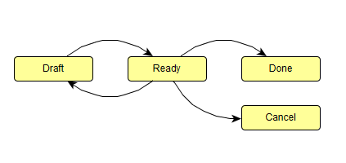

* Suggested URLs for Admin User Screens
  + Create ~/admin/survey
  + Update/Delete ~/admin/survey/1234
  + Get ~/admin/survey/1234
* Suggested URLs for Guest User Screens
  + ~/guest/survey/1234
* Activate/Deactivate a survey
  + Soft delete, survey will be accessible only in back office.
* Questions
  + Question types
  + Open response (text)
  + Multiple choice
  + No UI for Questions administration, but we will evaluate the SQL script/model.
  + Pre-Load questions into database using Migration-Seed method or SQL Script.
  + Multiple choice options must contain a ponderable value.
  + Multiple choice questions must contain at least 2 options.
* Report
  + Create a stored procedure
  + Use ADO.NET to consume the stored procedure
  + Display the report in a simple grid
  + Suggested URL for Admin User Screen
    - ~/admin/survey/report

Example

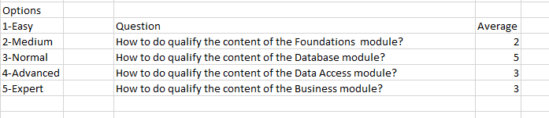

* + UI
    - All the screens must look clean and usable.
    - Use MVC or Angular JS for Admin User Screens development
    - Use MVC or Angular JS for Guest User Screens development
    - Don’t use the same technology for both module screens
  + Model

